ibruk Consulting Pvt. Ltd.

Tips & Tricks
Use Microsoft Word Effectively
Table of Contents
Using AutoText Effectively 3
Adding a Content Element to the AutoText Gallery 3
Using an AutoText Entry 5
Using AutoCorrect Effectively 5
Creating an AutoCorrect Entry 6
Using the AutoCorrect Entry 8
Selecting Text Quickly with a Mouse 8
Selecting a Word 8
Selecting a Line in a Paragraph 9
Selecting a Paragraph 9
Selecting a Sentence 10
Selecting Required Content 11
Using the Calculate Feature 11
Adding the Calculate Option to the Quick Access Toolbar 11
Using the Calculate Option 12
Using the Extend Mode 13

Using AutoText Effectively
As technical writers, we often have graphics or text that we need to reuse within a document or across documents.
For example, consider the following table, which we use to present a note. It is nothing but a formatted 2-column table with the note icon in the first cell and the note text in the second cell.
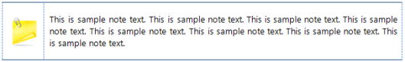
Every time you need to use a note in your content, you have to insert this table. One way is to copy and paste the table from elsewhere.
A simpler way is to use the AutoText feature of Microsoft Word. With the AutoText feature of Microsoft Word, you can save and reuse pre-formatted text and graphic elements.
Let us see how this can be done.

Adding a Content Element to the AutoText Gallery
- Format the text or graphic element you want to reuse.
For example, we created the table to represent the note.
- Select the formatted content element.
For example, we selected the note table.
- On the Insert tab, in the Text group, click Quick Parts and point to AutoText.
- In the gallery that opens, click Save Selection to AutoText Gallery.
The Create New Building Box dialog box is displayed.
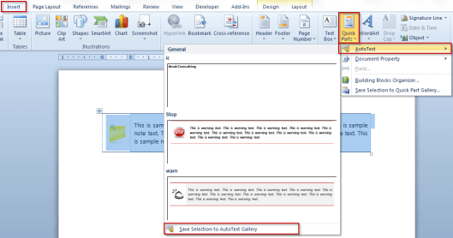
- Type a Name for the building block.
Keep the name short as we can use it as a shortcut.
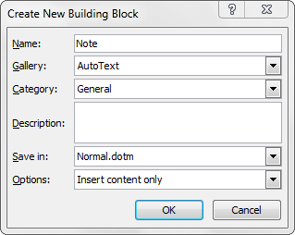
- Click OK.
The building block is now saved and visible in the AutoText Gallery.
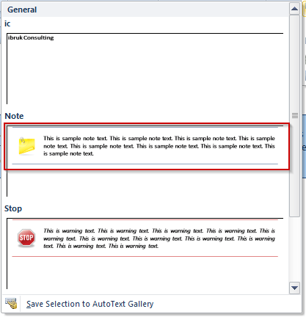

Using an AutoText Entry
- On the Insert tab, in the Text group, click Quick Parts and point to AutoText.
- Click the AutoText entry you want.
A simpler way to add an AutoText entry is to type the name of the AutoText entry and press F3 on the keyboard.
This is why we asked you to keep the name short. 🙂

Using AutoCorrect Effectively
In an earlier post, we had shown you how to use AutoText effectively. In this post, we take a closer look at yet another underrated feature of Microsoft Word called AutoCorrect.
With AutoText, you were able to save and reuse complex pre-formatted content units such as tables. However, many a time you need to use pre-formatted text such as product names. This is when AutoCorrect is useful.
For example, a company’s branding guidelines may require product names to be written as shown in the image below.
In addition, the guidelines may also require that the words in the product name should never be split across multiple lines. For example, the image below shows how the product name should never be written.
The correct way to write a product name is shown in the image below.
One way is to:
- Type and format the product name correctly.
- Use copy and paste to ensure that the product name is reproduced correctly.
A simpler way is to use make the product name an AutoCorrect entry and reuse it as and when required.

Creating an AutoCorrect Entry
- Type and format the text that you want to store as the AutoCorrect entry.
- Select the text.
- On the File menu, click Options.
The Word Options dialog box is displayed.
- From the list on the left, select Proofing.
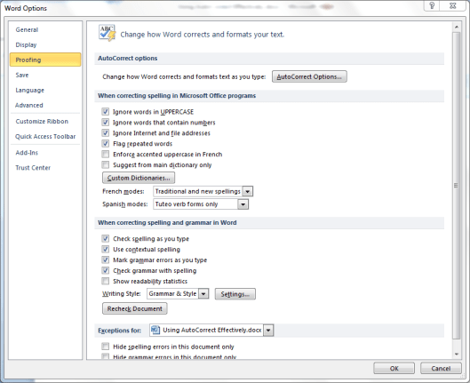
- In the right-pane, click AutoCorrect Options.
The AutoCorrect dialog box is displayed.
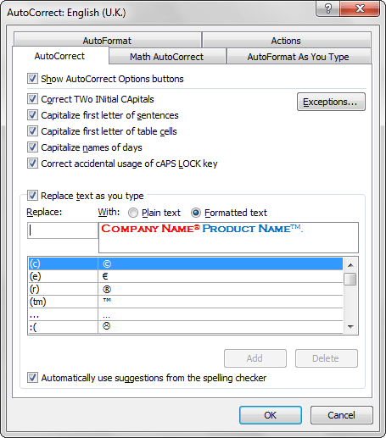
- In the Replace text as you type section:
  - Against With, ensure that Formatted text is selected.
The formatted product name is displayed in the text box under With.
  - In the Replace box, type a shortcut the you want to use to insert the product name. For example, pn.
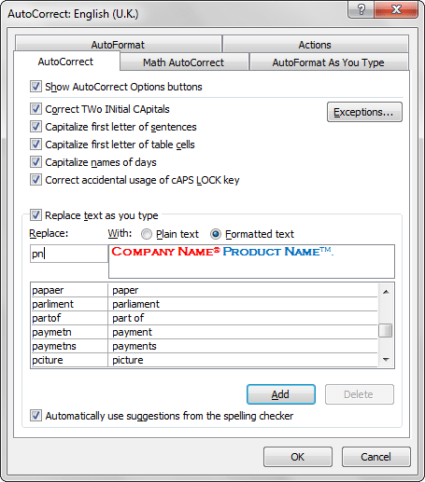
  - Click Add.
The entry is now displayed in the AutoCorrect entries.
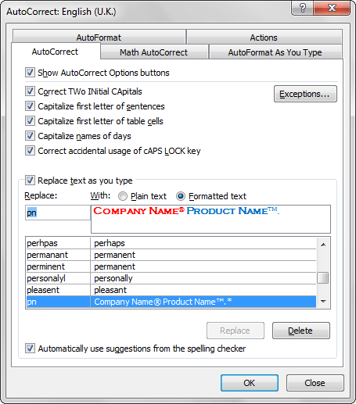
- In the AutoCorrect dialog box, click OK.
- In the Word Options dialog box, click OK.

Using the AutoCorrect Entry
- In any document, type pn and press the space bar.
The shortcut is replaced by the text.

Selecting Text Quickly with a Mouse
Selecting text is one of the most common tasks in Microsoft Word documents. Here are some quick and easy ways to select text in a document.

Selecting a Word
- Double-click the word to be selected.

Selecting a Line in a Paragraph
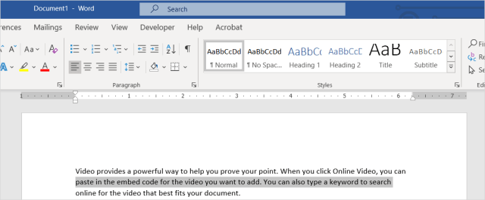
- Move the mouse cursor to the left margin in front of the line to be selected till it changes to .
- Click. The line gets selected.
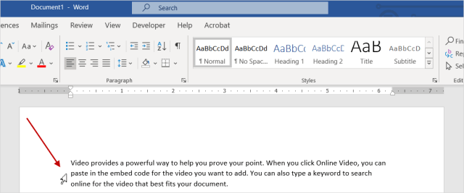

Selecting a Paragraph
- Move the mouse cursor to the left margin in front of the paragraph to be selected till it changes to .
- Double-click to select the paragraph.
Or
Triple-click anywhere in the paragraph.
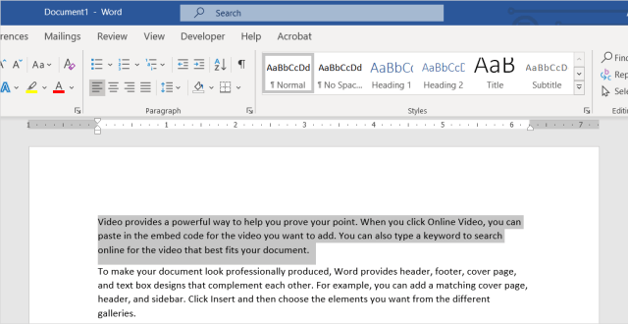

Selecting a Sentence
- Keep the CTRL key pressed, and click anywhere in the sentence to be selected.
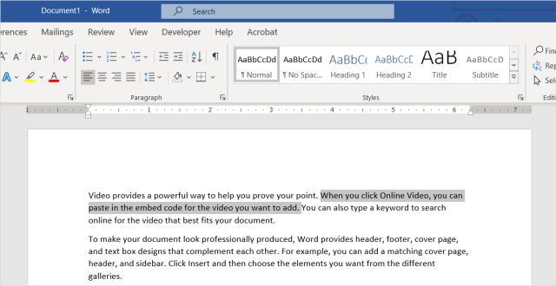

Selecting Required Content
- Click at the start of the word that is the start of the content to be selected.
- Keep SHIFT pressed and click at the end of the content to be selected. The required content is selected.
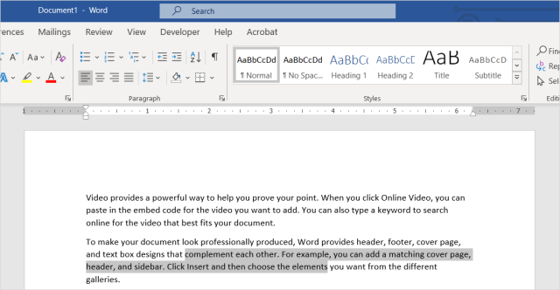

Using the Calculate Feature
Did you know that you can preview the result of a calculation in Microsoft Word? Here how simple it is.

Adding the Calculate Option to the Quick Access Toolbar
- Click the File tab.
- Click Options.
The Word Options dialog box is displayed.
- Click Quick Access Toolbar.
- In the right pane, from the Choose commands from list, select All Commands.
All available commands are displayed in the list below.
- Scroll through the list and click Calculate.
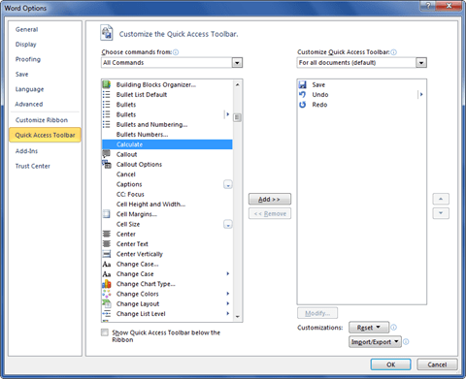
- Click Add > >.
- Click OK.
The calculate option is added to the Quick Access Toolbar.
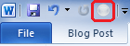

Using the Calculate Option
- Type an equation in the Word document.
- Select the equation.
- Click Calculate.
The result is displayed in the status bar.
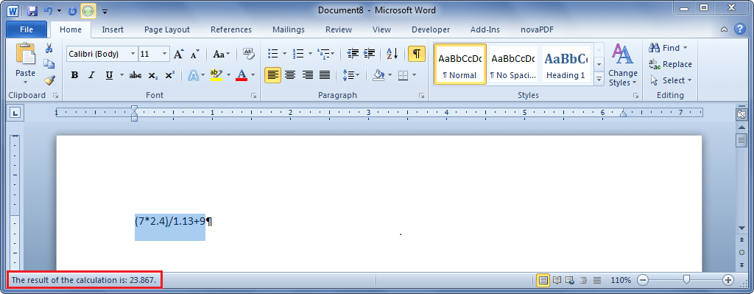

Using the Extend Mode
The Extend mode in Microsoft Word helps you select blocks of text quickly and easily. Here is a tutorial to show you how it works.
We will use the sample text generated by Microsoft Word to demonstrate this feature.

© ibruk Consulting Private Limited, India
All rights reserved. No part of this book may be reproduced in any manner whatsoever, stored in a retrieval system or transmitted or translated in any form or manner or by any means, without the prior written permission of ibruk Consulting Private Limited.
ibruk Consulting has made every effort in the preparation of this book to ensure the accuracy of the information. However, the information contained in this book is sold without warranty, either express or implied. Neither ibruk Consulting nor its licencees will be held liable for any damages caused or alleged to be caused either directly or indirectly by this book.
Contact Us
ibruk Consulting Private Limited
A-404, Mangalya,
Off Marol-Maroshi Road,
Andheri East, Mumbai 400059.
Website: www.ibruk.in
Tel: +91-22-29204260/1
Email: info@ibruk.in

